**E-Project: Specification - PHP - Online Shopping Cart**

**ONLINE SHOPPING CART**

|  |  |  |
| --- | --- | --- |
| **Supervisor.** | Miss IFRAH HAIDER | |
| **Batch.** | 2209c2 | |
| **Group.** | C | |
| **Serial No.** | **Enrollment Number** | **Student Name** |
| 1. | Student1415341 | AL RAYAN KHAN |
| 2. | Student1418389 | MAHNOOR . |
| 3. | Student1416097 | HUZAIFA SHEIKH |
| 4. | Student1415312 | MUHAMMAD HAMZA |
| 5. | Student1416109 | ABUBAKAR |

**E-Project: Specification - PHP - Online Shopping Cart**

# ACKNOWLEDGEMENT

**The first, we would like to express my special thanks of gratitude to my teacher Miss Ifrah Haider, who helped us a lot in finalizing this project within the limited time frame, valuable counselling and assistance for the accomplishment of this project.**

**Secondly we would also like to thank the E-Project team at Aptech Head Office, who gave us the golden opportunity to do this wonderful project about Care**

**Thirdly, we also thank the E-Project team, some of the benefits are as under:**

* **Re-enforcement of skills happens in the experiential learning process.**
* **A mentor, ensuring that we do not get drifted, constantly guides us.**
* **It gives us a lot of confidence to face an interview as we have worked on a project. We can explain virtually everything on the subject we have learnt.**

**E-Project: Specification - PHP - Online Shopping Cart**

# SYNOPSIS

**The Objective of this program is to give a sample project to work on real life projects. These applications help you build a larger more robust application.**

**The objective is not to teach you concepts but to provide you with a real life scenario and help you create applications using the tools.**

**You can revise them before you start with the project.**

**It is very essential that a student has a clear understanding of the subject.**

**Kindly get back to eProjects Team in case of any doubts regarding the application or its objectives**

**E-Project: Specification - PHP - Online Shopping Cart**

# PROBLEM DEFINITION

**Problem statement is attached separately in a file “Online Shopping Cart”**

**Standards plan:**

**Every code block must have comments.**

**The logic of the program needs to be explained. Proper documentation should be maintained.**

**Complete Project Report along with synopsis, code and documentation should be prepared.**

**Documentation:**

**No project is complete without documentation. In fact, it is one of the most important activities during the development of a project. The documentation of an ideal project will be in the form of a project report comprising of the following documents:**

* **Certificate of Completion.**
* **Table of Contents.**
* **Problem Definition.**
* **Customer Requirement Specification.**
* **Project Plan.**
* **E-R Diagrams.**
* **Algorithms.**
* **GUI Standards Document.**
* **Interface Design Document.**
* **Task Sheet.**
* **Project Review and Monitoring Report.**
* **Unit Testing Check List.**
* **Final Check List.**

**Note: Name: AL RAYAN KHAN, Address: New Karachi Godhra House no.1c Sector.11D , Phone Numbers: 03110019934, Email-id: alrayankhan11@gmail.com should be mandatory to be provided.**

**E-Project: Specification - PHP - Online Shopping Cart**

# CUSTOMER REQUIREMENT SPECIFICATION (CRS)

* **Maintaining the details of the Employees, product details, stock details, order, and delivery details of the products and that of the customers are to be maintained with the help of the database.**
* **There should be separate login for Admin, Employees and for the customer.**

**E-Project: Specification - PHP - Online Shopping Cart**

# SCOPE OF THE WORK (IN BRIEF)

**After all, the primary objective of a online Shopping card website is** **to provide as many avenues to prospective customers as possible to create an interest in them for the Shopping**

**E-Project: Specification - PHP - Online Shopping Cart**

# WIREFRAMES

1. Login Form

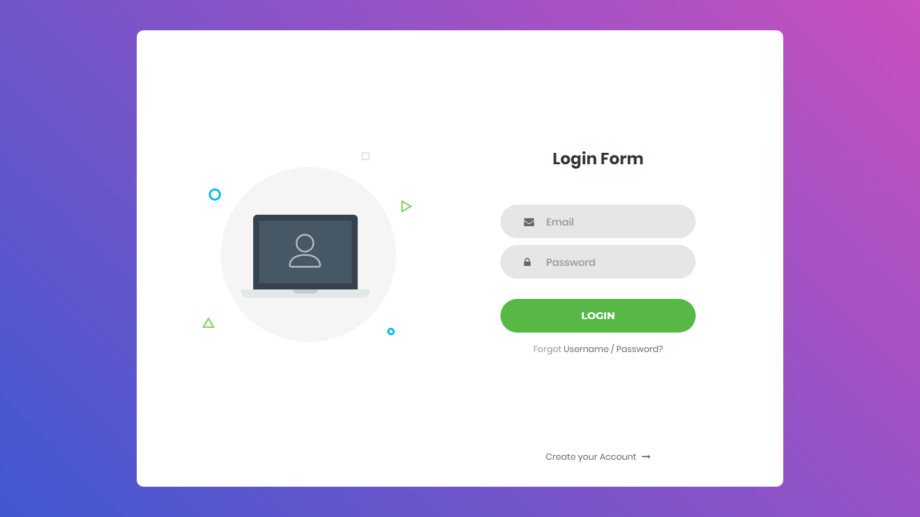

2 . Dashboard

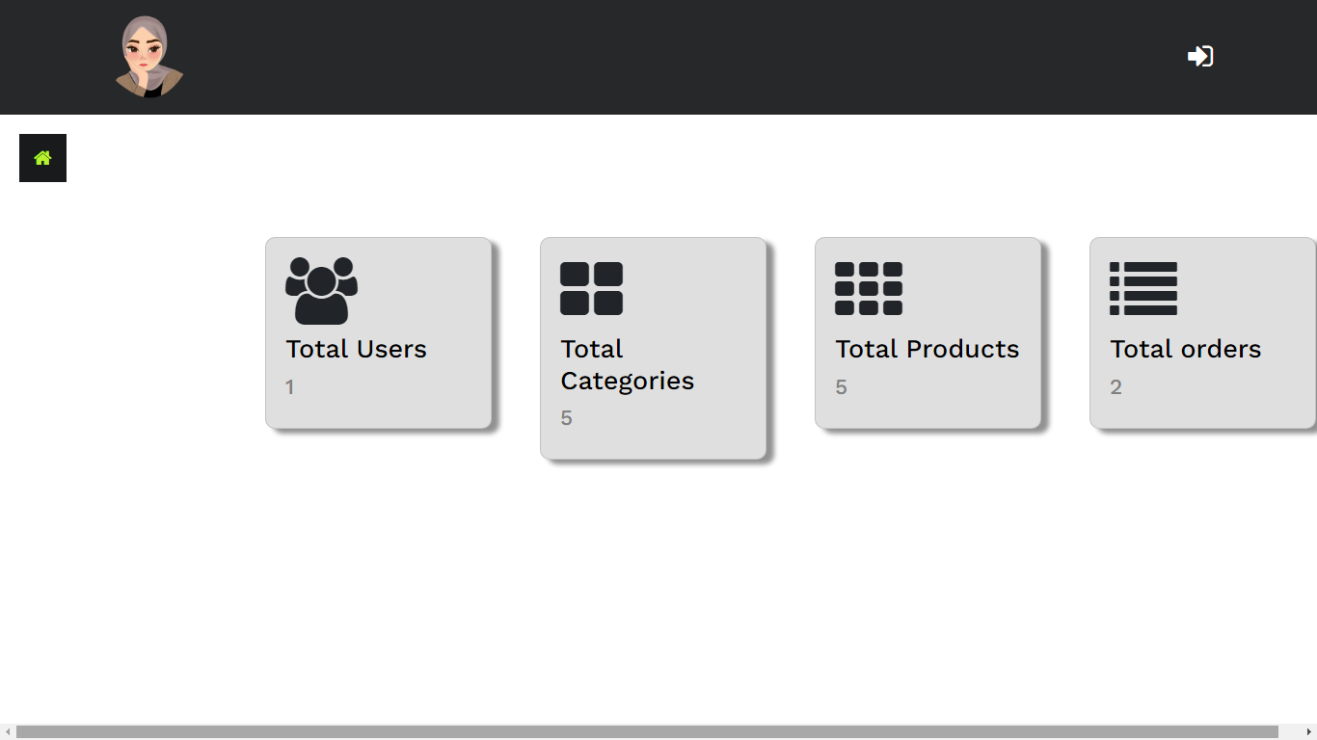

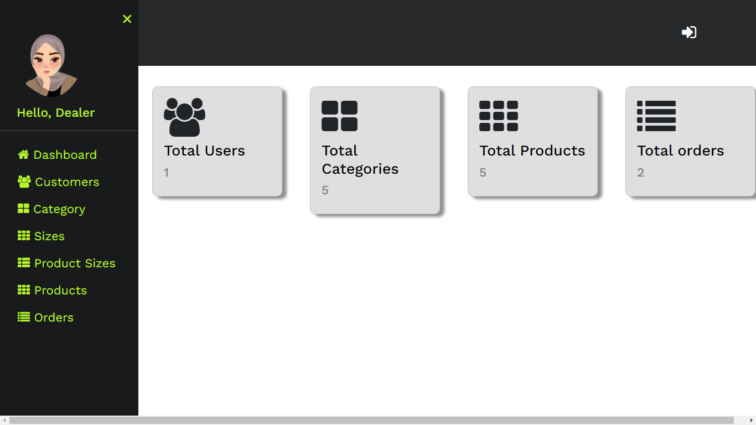

3 . ALL Customers

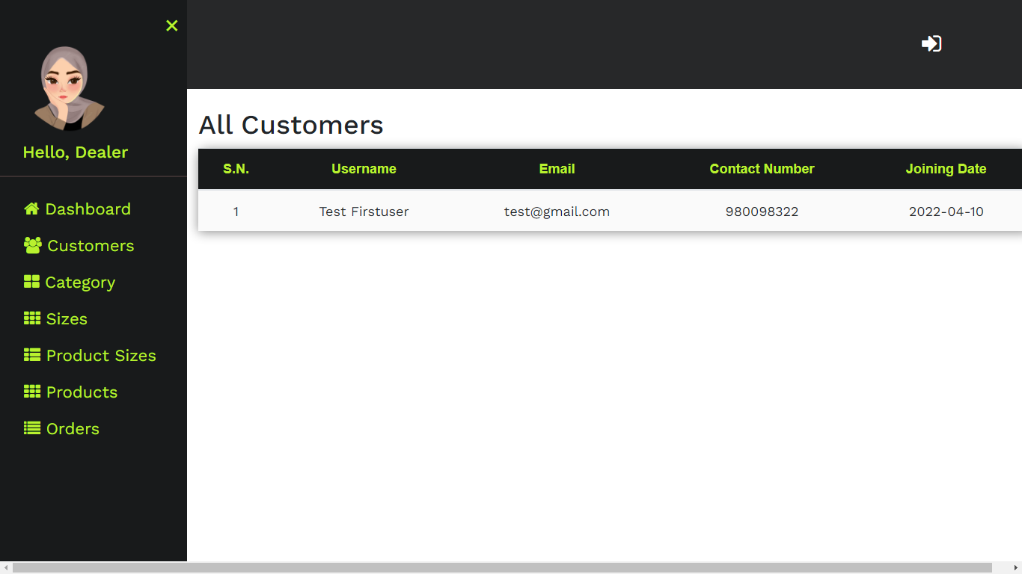

4 . Category Items

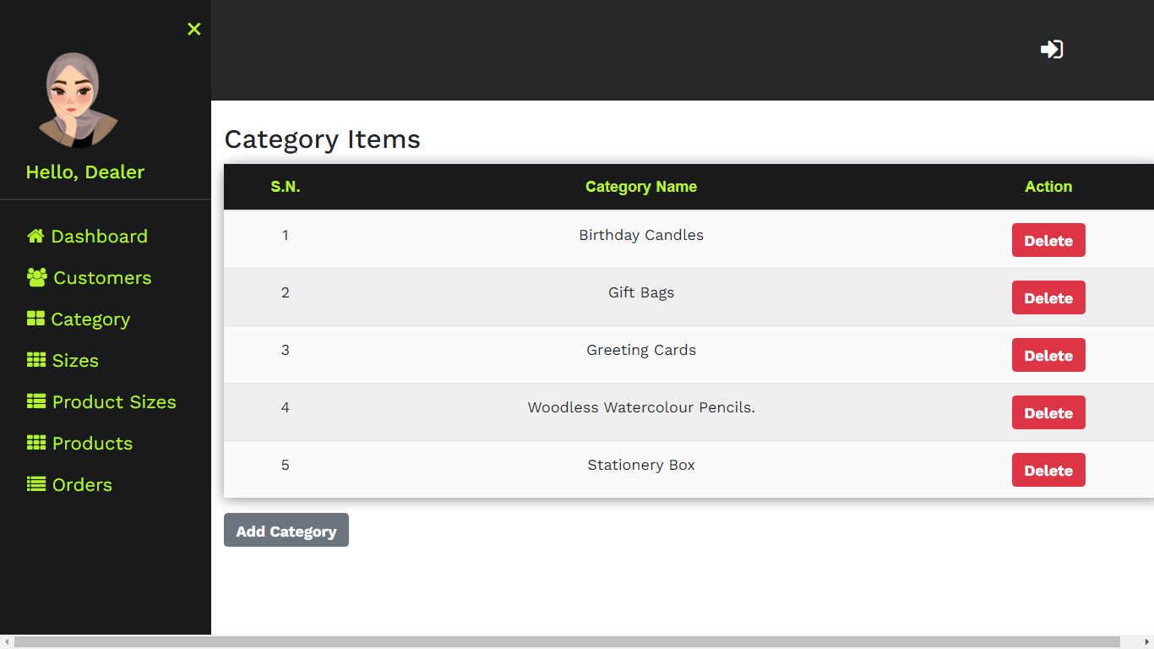

5 . Available Size

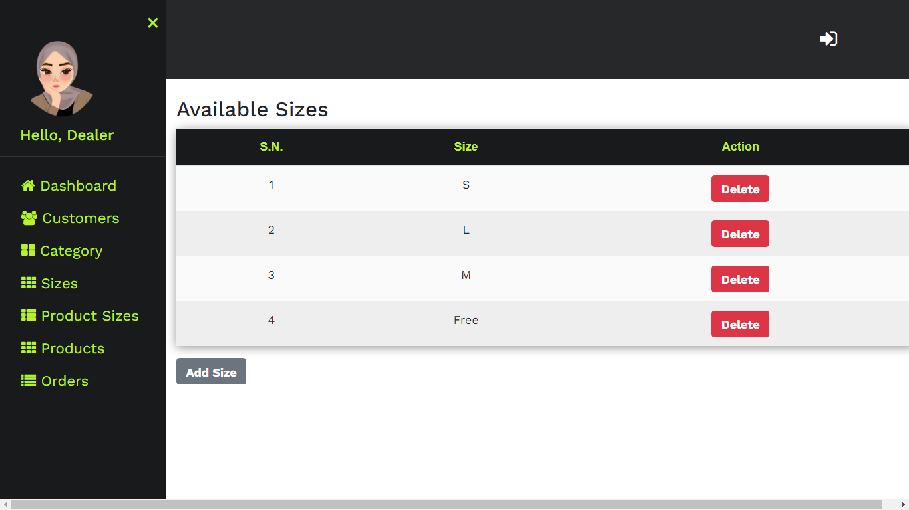

6 . Product Size Item

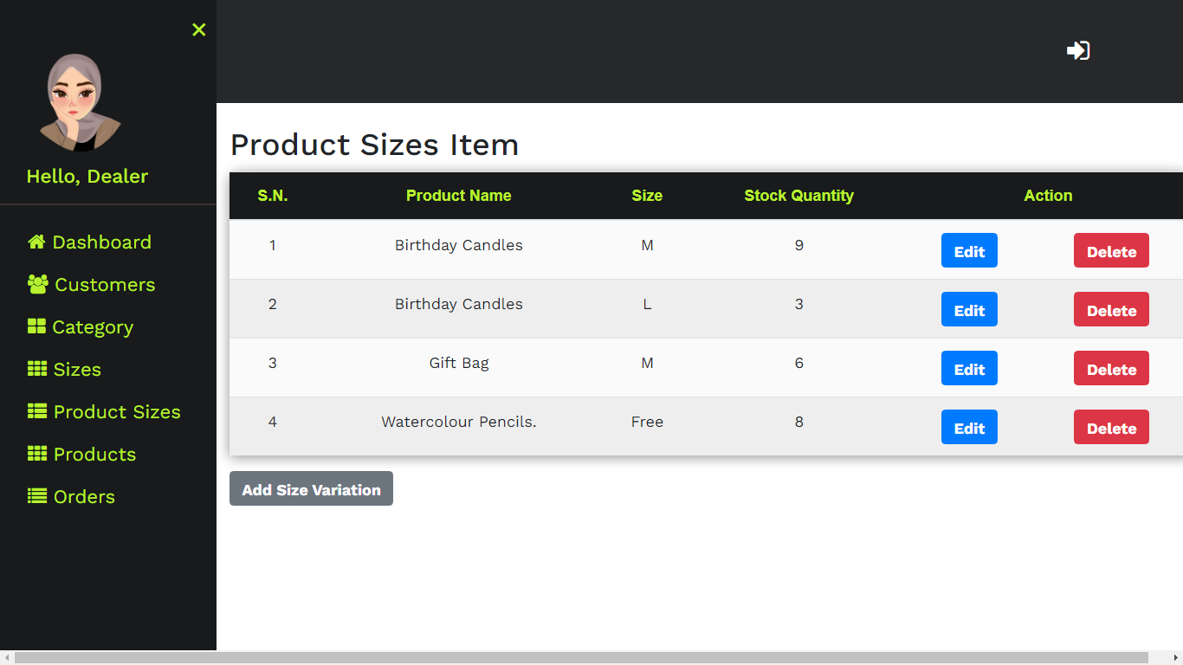

7 . Product Items

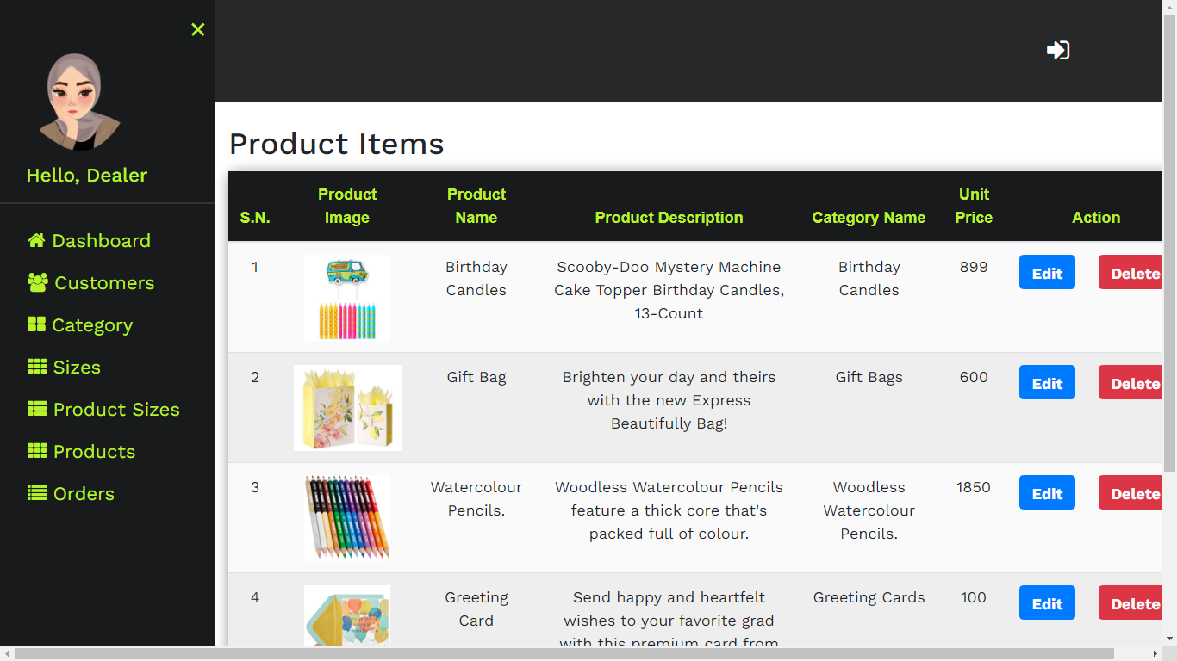

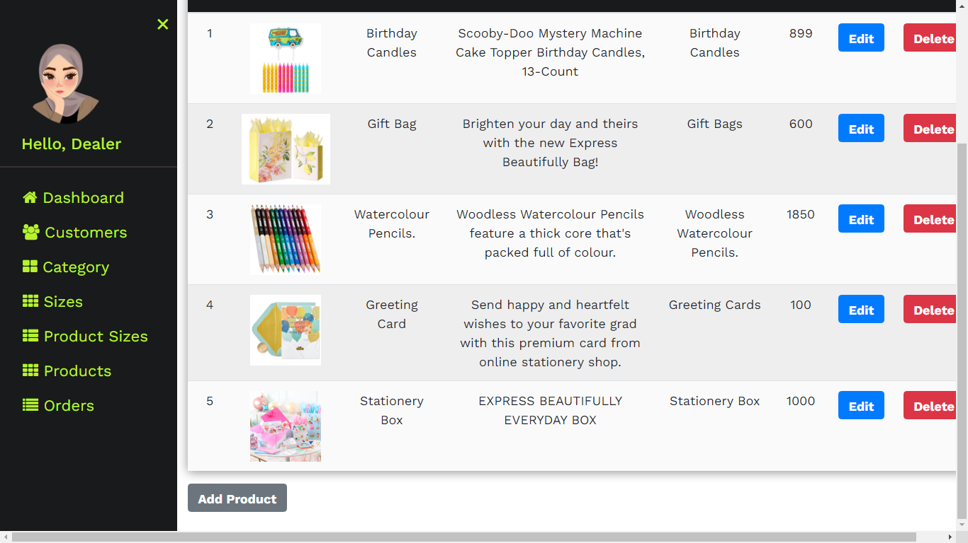

8 . Order Details

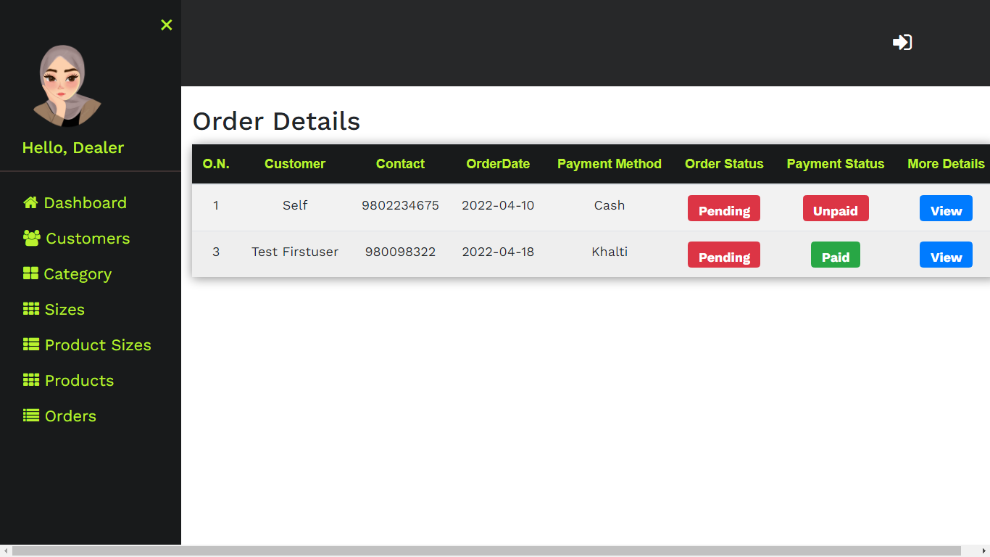

9 . Sign up

